Tree Top trekking.

Tuesday, March 31, after a snowday, we finally arrived after 2 hard hours in an old school bus at Eagle Crest Aerial Park far away from Orillia.
At our arrival, a team was waiting for us in order to get us ready before climbing in the trees. For instance we were told many times to : ALWAYS, ALWAYS, ALWAYS BE ATTACHED !
Therefore, to show that we understood, we went on a training course on the ground. Then we started our tour in the trees, with a beautiful Sun and...but freezing temperatures !
Eaglecrest Park
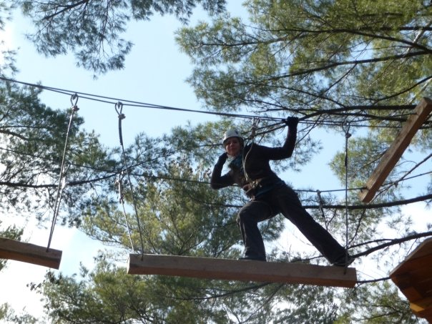
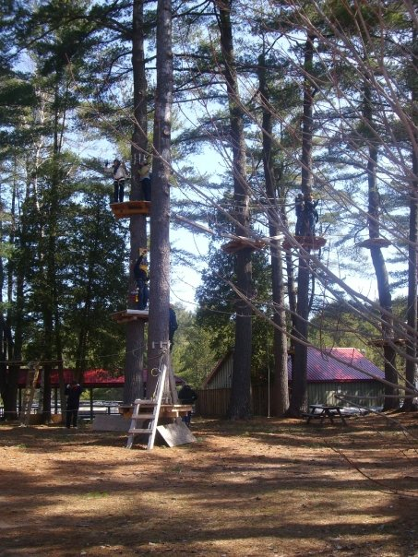
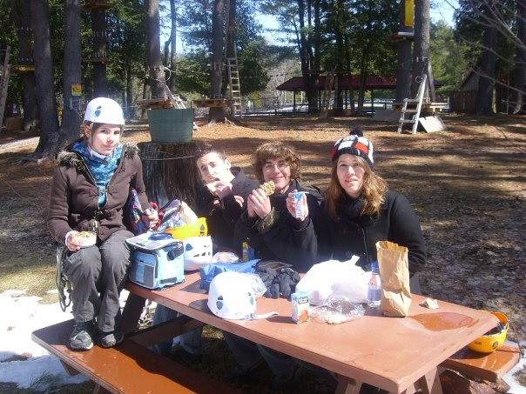
The trunk course starring Ariane
After lunch, we experimented the BIG ZIP-LINE !
We crossed a frozen lake in the air.
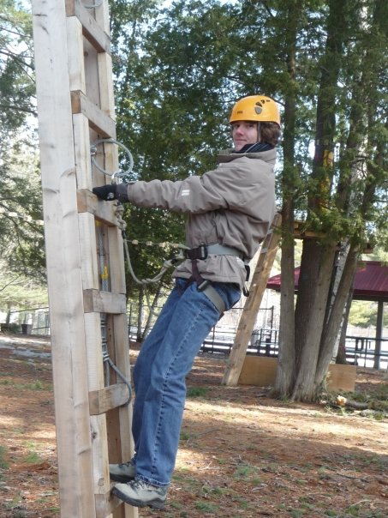
Romain... happy before zip-lining

Around, 1:00 p.m, we left the spot and went back to Park Street in our blue bus (with Sam The Driver).

