With this activity we are going to practice the correct use of the verb have (Have-Has) and the verb to be (Am-Are-Is)
Fill in the blanks with the correct auxiliar or verb.

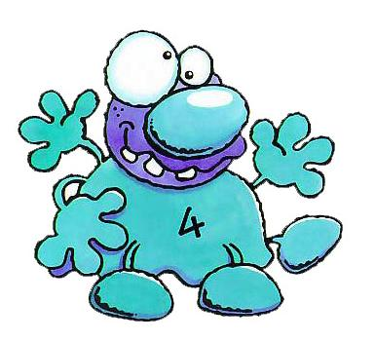
Hi! I____ Pow.

I _____103 years old.

I _____got three hands and three legs.

My nose _____very big.

I ____got two eyes.

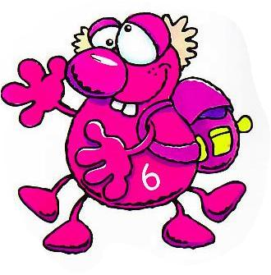
One eye ____small and the other ____big.

They _____my best friends: Fify and Mud.

Fify______102 years old.

She _____pink and pretty.

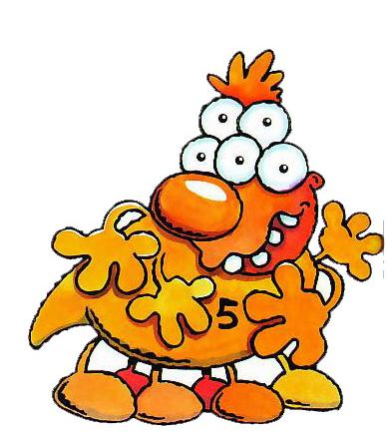
She ______got two hands and four legs.

Her nose _____big and she _____got two eyes

Mud _____104 years old.

He _____orange and funny.

He _____got six legs and four arms.

His nose_____ very big and he ____ got five eyes!

